The University of Nottingham

DEPARTMENT OF MECHANICAL, MATERIALS AND MANUFACTURING ENGINEERING

A LEVEL 4 MODULE, AUTUMN SEMESTER 2023-2024

COGNITIVE ERGONOMICS IN DESIGN

ANSWER SHEET

Time allowed TWO Hours

No calculators are permitted in this examination.

Dictionaries are not allowed with one exception. Those whose first language is not English may use a standard translation dictionary to translate between that language and English provided that neither language is the subject of this examination. Subject specific translation dictionaries are not permitted.

No electronic devices capable of storing and retrieving text, including electronic dictionaries, may be used.

DO NOT turn examination paper over until instructed to do so

ADDITIONAL MATERIAL: None

INFORMATION FOR INVIGILATORS:

Question papers should be collected in at the end of the exam – do not allow candidates to take copies from the exam room.

- Describe the cognitive ergonomics underpinning human error. Make reference to Skill, Rule and Knowledge based behaviour in your answer. Use application examples to support your answer. [33]

Answers should draw from the following:
From Reason, 1990:

Depicts the intent behind the “error”​
- Slips/lapses​
  - Occur when the correct way of performing an action is known, but, often due to a lapse of attention, it is performed wrongly​
- Mistakes​
  - The use of an inappropriate action for the situation​
- Violations​
  - Deliberate decision to perform what is known to be an inappropriate or unsafe act​

According to Reason (1990), the types of human failure are few in number. In fact, safety critical organizations categorized these errors into two major categories which are deliberate erroneous conducts and unintended conducts (Dyer and Scagnoli, 2020). The deliberate errors are violations while slips, lapses and mistakes are types of unintended errors also known as human failure. The main distinction is that mistakes are the result of planning errors, whereas slips and lapses are the consequence of implementation failure such as inattentiveness, distraction.

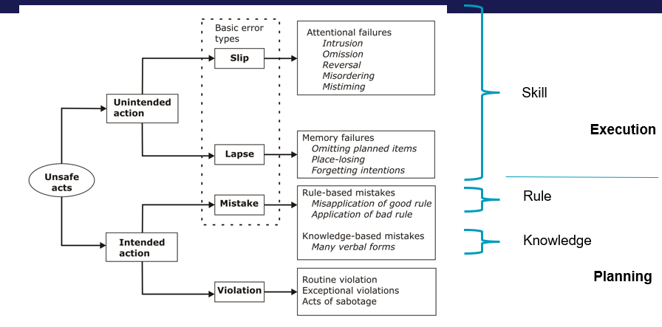

The Skill, Knowledge, Rule (SKR) taxonomy of human errors was proposed by Rasmussen (1982) as a useful framework for recognising and grouping the various forms of human errors and not violations. Human errors are divided into two categories in the SKR framework: execution and planning errors. A skill-based error occurs when someone has evidently failed to implement or practically perform the critical task in a satisfactory manner such as when one forgets to arrange something in the proper order or skips a step in a process.
The most prevalent errors are skill-based errors, which occur when a person has the necessary abilities, has a lot of experience, and is very familiar with the routine and regulations, yet unwittingly commits an error (Rasmussen, 1982; Salminen and Tallberg, 1996). Examples of skills-based errors includes when one misses a step, hit the wrong button, loosen instead of tightening something, or performs any action on autopilot (Dyer and Scagnoli, 2020). Slips and lapses are examples of skills-based errors.
Slips and lapses can be defined as errors that occur as a result of a failure in the implementation and/or storage stage of an action cycle, irrespective of whether or not the plan that directed them was suitable to accomplish their goal (Reason, 1990). Workers make these errors when they fail to make a cognitive attentional check due to:
Strong habitual intrusions in which the procedure or behaviour is not frequent
Omission in which one is prevented from making the essential checks because of distractions
Mistimed checks that occur when workers underestimate intervals within a series of actions

GEMs – the application of Rasmussen’s SRK ideas in the area of human error identification.
GEMs is an attempt to integrate error at SB, RB, KB.
SB=preprogrammed behavioural sequences, with checks. Check if actions are running to plan, and if goal is being achieved. Slips and lapses depend upon failures of attentional checking – either inattention (failure to make a check) or overattention – checks at inappropriate points.
Humans are strong pattern recognisers – rather than calculate or optimise – i.e. when given a problem, humans are strongly biased towards solutions at RB level rather than more effortful kB level. Inclination to exit along “is pattern familiar?” route in RB. Only with cycles of this failing to offer a satisfactory solution will they move to KB. Here, they will still tend to RB. Strong bias towards simplifying problems based on existing patterns/rules.
Can be applied to determine the type of behaviour that has led to, or could lead to, an error.
In particular, helps distinguish between slips and mistakes.
Slip=departure of action from intention (the operator knows what to do, but does the wrong thing)
Mistakes = operator acts according to plan, but selects inadequate plan to achieve the desired outcome.
Importantly, S&M are caused by different behavioural processes and need to be eradicated by different solution.
e.g. slips might be lack of attention – these are already experts so training would not be of use.

Other points could include differentiation between acts of omission (similar to lapses) vs commission (similar to slips). Also active vs. latent failures, but this speaks less to the underlying cognition.

Several examples given in class (e.g. slip of going into wrong toilet; slip error while eating hotpot; lapse error – leaving emergency phones connected. The HSE failure types also gives several examples of errors. Also, could draw from the extended examples given in class e.g. TMI; Ladbrook Grove disaster.

Higher marks (23+) will be awarded for comprehensive answers, correctly covering most of the main points above, using appropriate reference to SRK behaviour, and suitable application examples. 20-23 marks will be awarded for less comprehensive answers with minor inaccuracies. 16.5-19 marks will be awarded for responses which report on the basic information. <16 marks will have missed key points provided limited information or have significant inaccuracies.

- (a) Describe Situation Awareness, making reference to Endsley’s model. [22]

(b) Explain approaches that can be used to support Situation Awareness. Illustrate your answer with application examples. [12]

Answers should draw from the following:

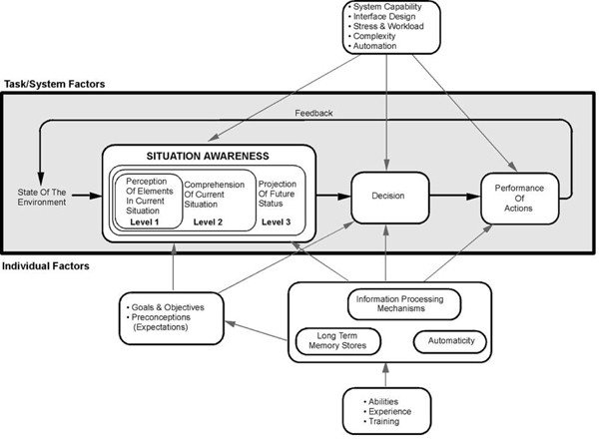

- Enhancing operator situation awareness (SA) is a major design goal in developing interfaces (originated from aircraft piloting domain)​
- Operators ‘must perceive and comprehend a dazzling array of data which is often changing very rapidly’ (Endsley, 2000)​
- Problem is often not lack of information but finding appropriate information at the correct time​
“The perception of the elements in the environment within a volume of time and space, the comprehension of their meaning and the projection of their status in the near future” (Endsley, 1998)​
- Consists of three hierarchical “cognitive levels”​
- Higher level relies on outcome of the lower levels​
  - Level 1: Perception of the Elements in the Environment​
  - Level 2: Comprehension of the current situation​
  - Level 3: Projection of future status​
- SA = more than simply perceiving information about the environment

- Highly temporal in nature​ - changes continuously in dynamic environments
- Cannot be built up instantaneously, but forms over time​
- ​Has to be distinguished from the processes used to achieve it​
- SA cues can be received through all our senses (people are very active in SA process)​
- Does NOT comprise “static knowledge sources” such as procedures, rules and checklists​
- Importance of operator goals ​
- Has a close relationship with, but is separate from, decision making.​
- How someone directs attention has an impact on SA.
- Perception is a critical component
- Limits of working memory pose a constraint.
- SA is inter-related but independent of workload.

Part B: Approaches to support:

- Information must be usable cognitively. Does the system design support the user in gaining the needed information under dynamic operational constraints?
- Provide displays and interfaces that allow SA to be maintained​
- Consider enabling projection using additional interface elements (e.g. Projected movement of aircraft)​
- Ensure knowledge in the world to reduce memory burden for SA maintenance​
- Consider how different methods of SA measurement can be used to inform design and embed HF in integrated decision making​
- Training to improve SA , as done following the Air France Airbus A330 disaster.

Examples covered in class include the Air France Airbus A330 disaster, and a fire alarm evacuation. Other suitable examples are acceptable.

Part a: higher marks (15+) will be awarded for detailed description of SA, covering most of the main points above and a good description of Endsley’s model of SA. Marks will be deducted for less comprehensive answers and inaccuracies. Lower marks (<11) will be awarded when answers miss key info, or have fundamental errors.

Part b: higher marks (8+) will be awarded for detailed answers which give convincing descriptions of approaches to support SA and suitable application examples. Marks will be deducted for missing key points, inaccuracies or less convincing application examples.

- (a) Describe human attention, making reference to one theory or model of attention used in cognitive ergonomics. Illustrate your answer with an application example. [24]

Answers should draw from:
Introduction​
- Humans have several channels of sensory input​
- One input channel can receive many pieces of information​
Definitions​
- No precise definition available​
- Can be considered as a spotlight and a resource for other cognitive processes.
- Concept of “selectivity”, focus of mental effort​
- Cognitive process involved in shift of mental effort​
- It is possible to (apparently) concentrate on more than one thing at a time​
- Not always conscious of making decision about where attention should be focussed

Why are we so concerned with attention?
- Human beings need to handle increasingly complex environments​
- Historically human-machine systems were restricted by machines of variable quality​
- There is now more room for human error than machine error​
- Therefore we need to understand how to process the information available to us and to execute our responses​
- Human operators are provided with so much information that they need to know:​
  - Which information must be attended to​
  - Which information can be ignored safely

- Considering relationship between design and attention ​
- Both appropriate and inappropriate ‘drawing’ of attention​
- Using a multimodal approach​
- Understanding the need to sustain attention during longer interactions

Different types:

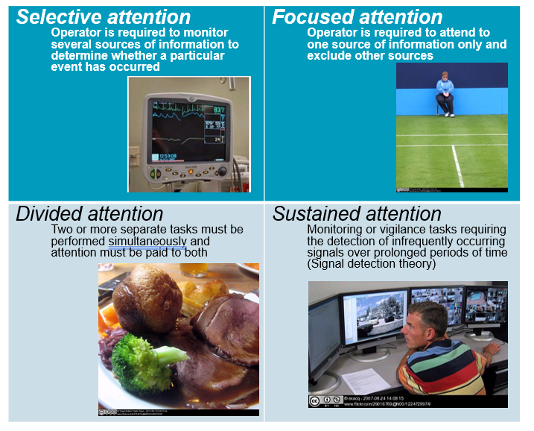

Theories/models could include:
Human Information processing (Wickens):
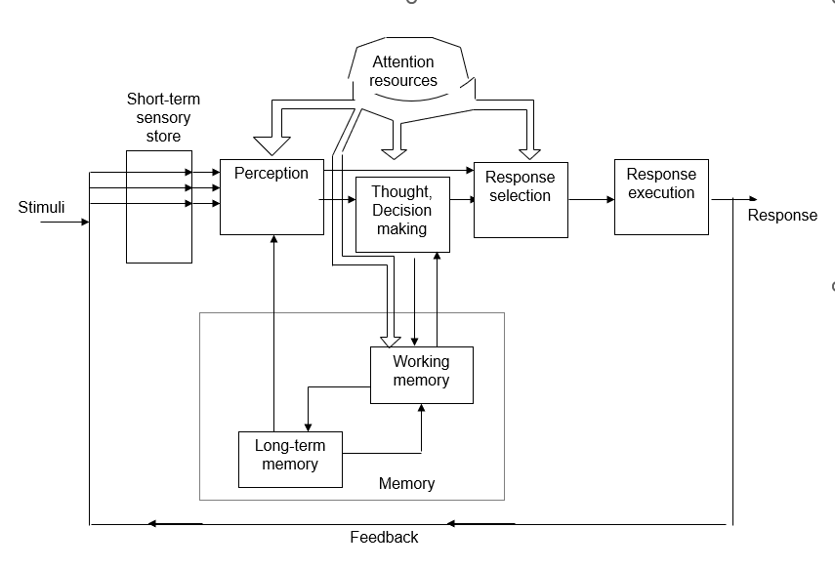

- Broadbent
  - Inputs selected at early stage of processing, on basis of physical characteristics (e.g. pitch of voice, position of speaker etc.)
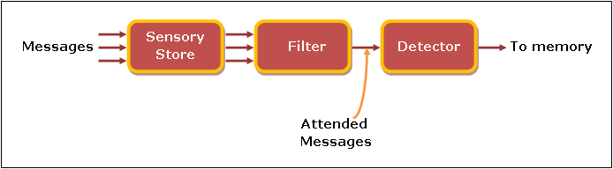
Cocktail Party Effect
  - Ability to hold individual conversations despite number of other noises present in room

- Treisman
  - Three types of processing until inputs distinguished:
    - Physical characteristics of stimuli assessed
    - If linguistic – separate into syllables and words
    - Assign meaning to stimuli
    - Non-selected stimuli attenuated – not completely rejected
Attended ear | Unattended ear
In the picnic basket she had peanut butter book, leaf, roof, sample, always…. | Cat, large, day, apple, friend, every, select, sandwiches and chocolate brownies

People asked to attend one ear…read these words…what they heard is underlined…thus people don’t only attend the intention, but the meaning.

Late selection model:
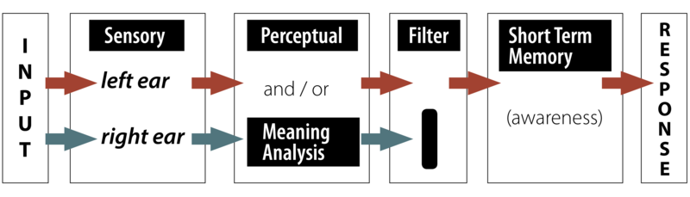

Late Selection​
- All stimuli processed​
- Selection occurs in working memory​

A late selection or response selection model proposed by Deutsch and Deutsch (1963) suggests that all information in the unattended ear is processed on the basis of meaning, not just the selected or highly pertinent information. However, only the information that is relevant for the task response gets into conscious awareness. This model is consistent with ideas of subliminal perception; in other words, that you don’t have to be aware of or attending a message for it to be fully processed for meaning.

Capacity models of attention​
- Attention = set of cognitive processes for categorising and recognising stimuli.​
- Cognitive resources = limited​
Practice – reduces the level of resources necessary to complete task​
- Kahneman identifies his theory as a capacity theory of attention, meaning: (1) attention is not an unlimited resource and (2) attention is a shared resource.

Load theory:
Load theory of attention (Lavie et al., 2004)​
- Distractor rejection depends on the level and type of load involved ​
- 2 selective attention mechanisms: ​
  - a perceptual selection mechanism serving to reduce distractor perception in situations of high perceptual load and ​
  - a cognitive control mechanism that reduces interference from perceived distractors as long as cognitive control functions are available to maintain current priorities (low cognitive load).

Signal detection theory:

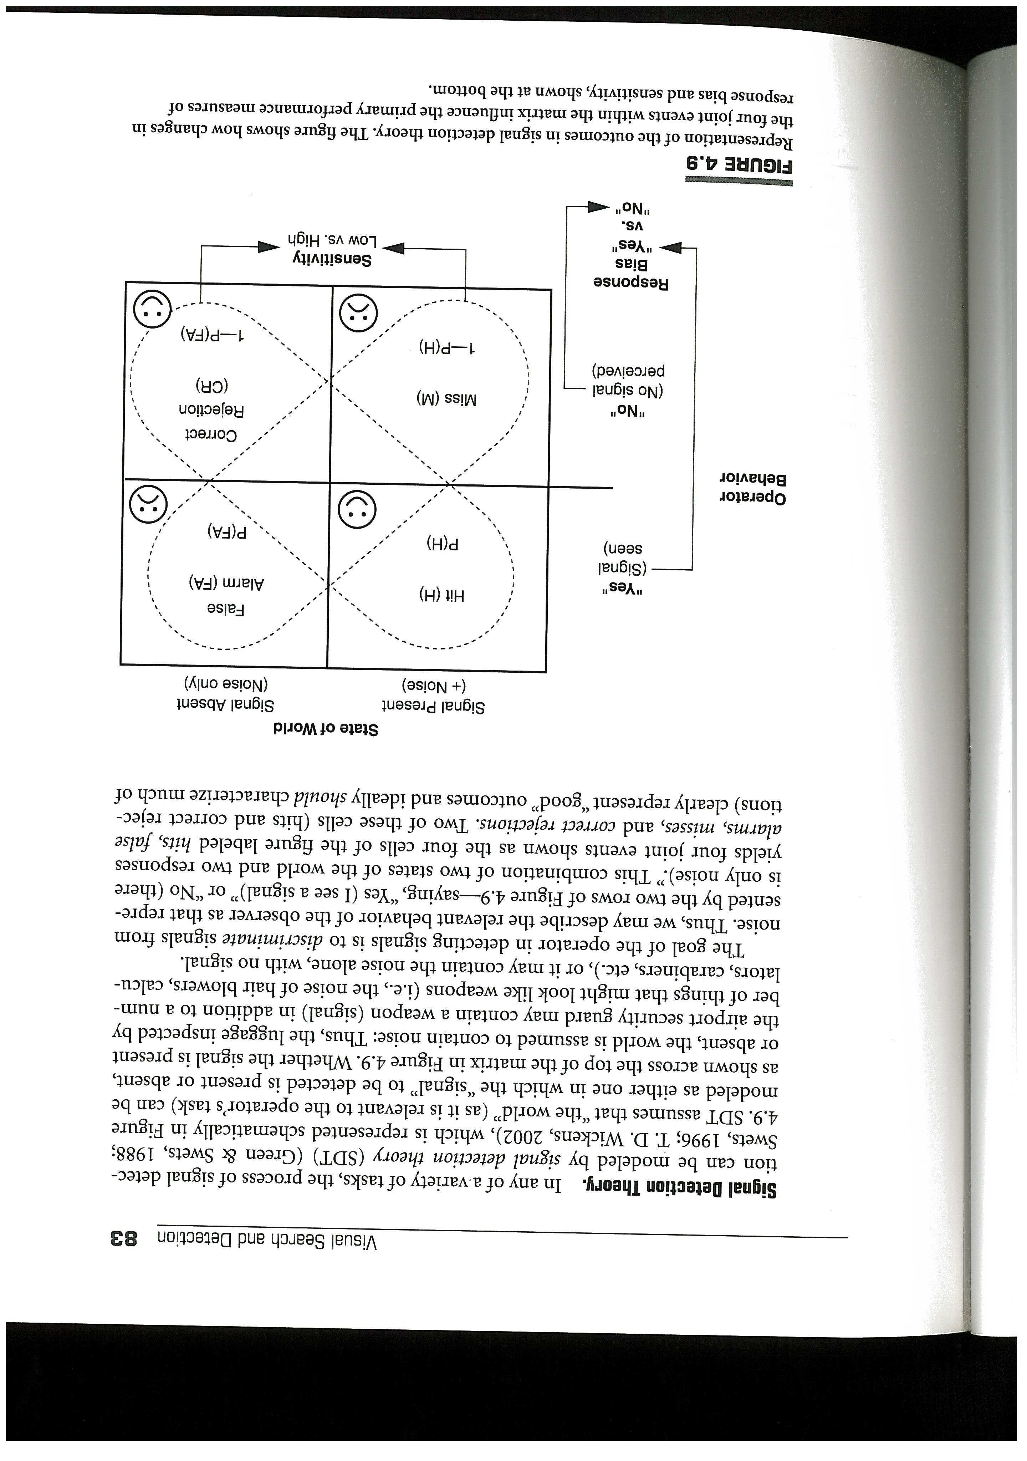
- Detection of signals in ‘world’​
- Assumption of noise present in world​
  - E.g. non dangerous items in luggage​
- Aim: discriminate signals from noise​
- Four outcomes: ​
  - Hit (signal present)​
  - Correct rejection (only noise present)​
  - False alarms (think signal present when not)​
  - Miss (fail to detect signal that is present)​

Suitable examples could be taken from a wide range of tasks where attention plays a key role, for example, driving, piloting, train driving, air traffic control, manufacturing quality control etc.

- Critique the use of eye-tracking for analysing human attention. [9]

Modern eye trackers generally use IR technology. Can calibrate rapidly, and generally give participants good freedom of movement. Software can help automate some of the analysis, by adding in areas of interest, but can still take considerable time. Tend to be either wearable or remote. Generally feasible for HF investigations. Generally good for studying visual attention (via focal points, durations). There is however difficulty linking gaze patterns with cognition.

Part A: higher marks (16.5+) will include detailed description of attention, presenting a suitable model/theory of attention and illustrating the example with a suitable application area. The description will cover most of the main points above and the model/theory will present a detailed description, making reference to the original author. Lower marks (14-16) will be awarded for less detailed answers, minor inaccuracies, or less suitable examples. 12-14 marks will be awarded for more basic answers, but which are fundamentally correct. <12 marks will be awarded for answers which fail to present the main points or have major inaccuracies.

Part B: 6+ marks will be awarded for detailed answers covering most of the points above. Marks will be deducted for less detailed answers or inaccuracies.

END

